CS543 Assignment 4

**Your Name:** Kaylin Chen

**Your NetId: tc49**

# Part 1 Single-View Geometry:

​​Plot the VPs and the lines used to estimate them on the image plane using the provided code.

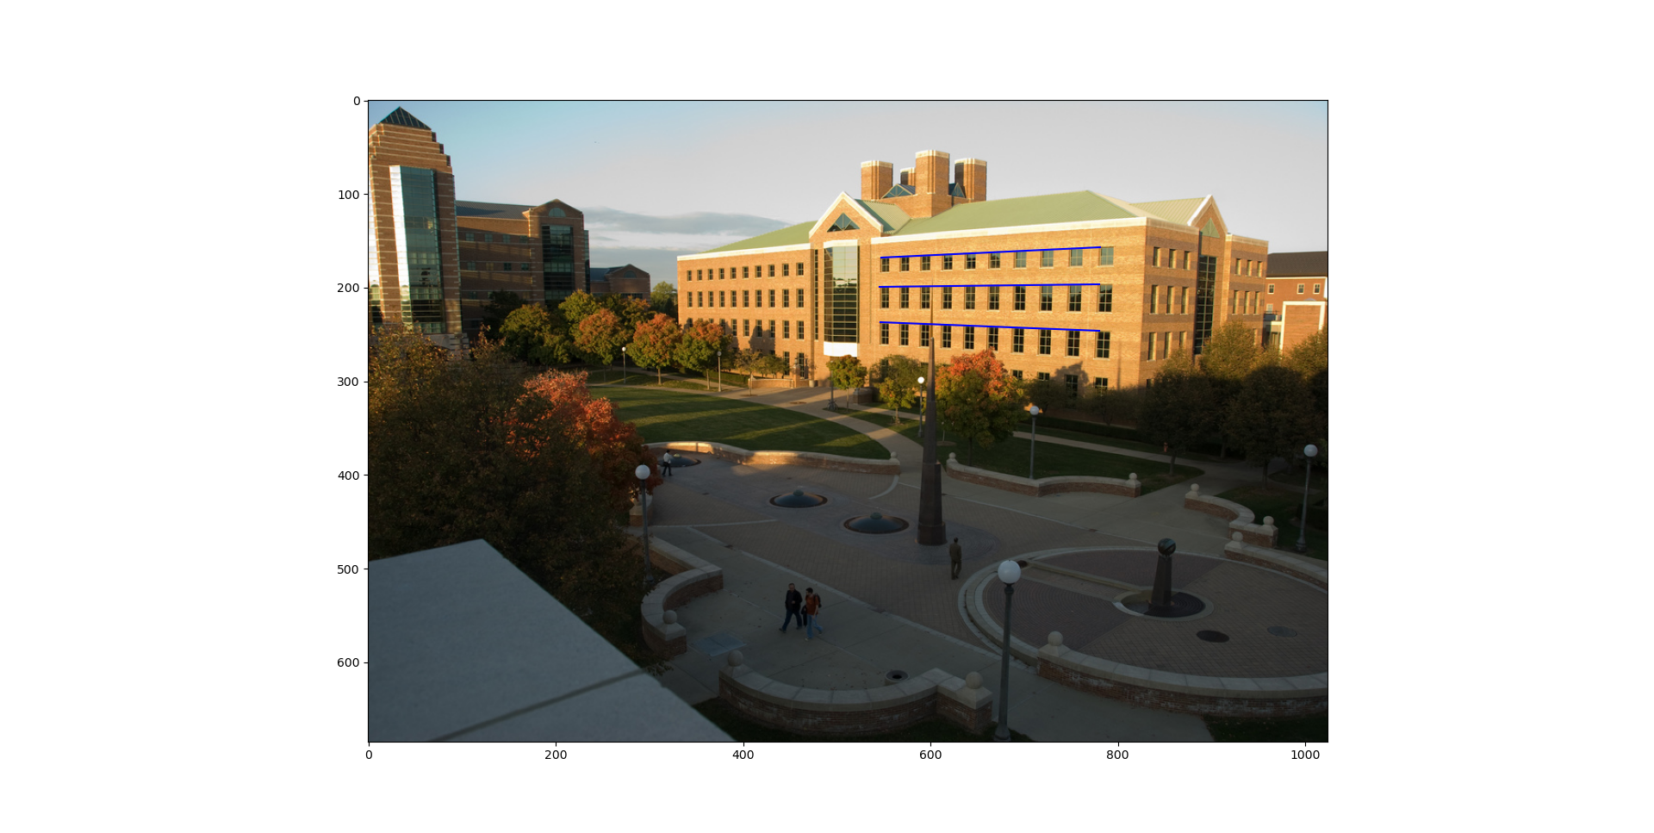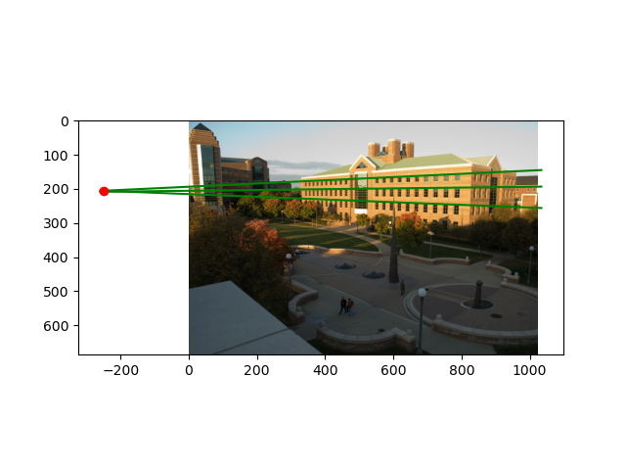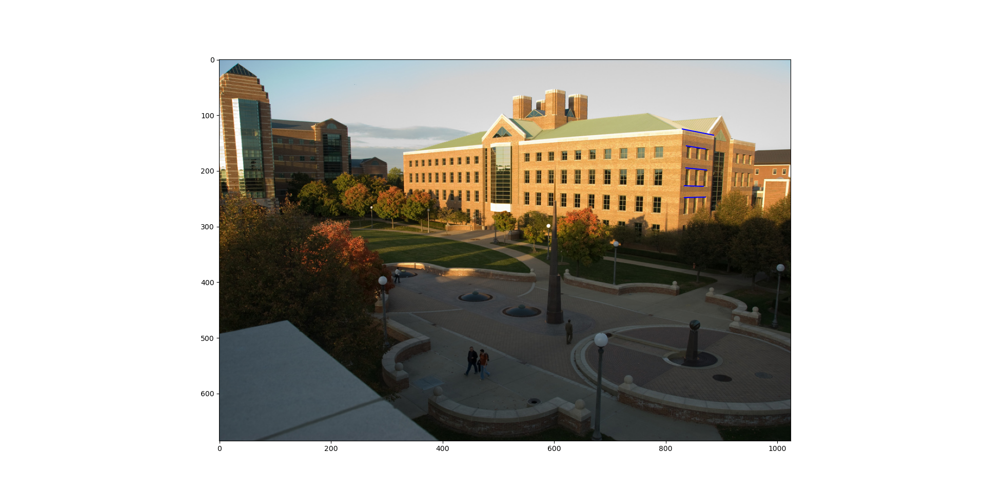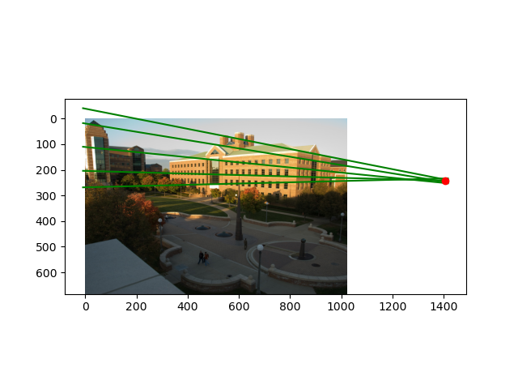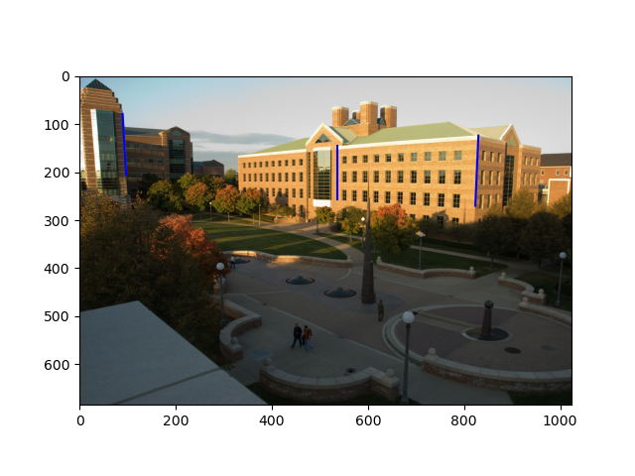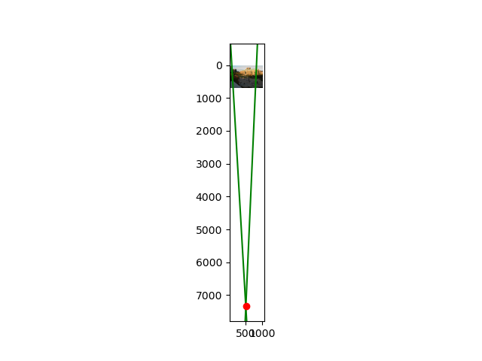

Specify the VP pixel coordinates.

vp1 pixel: -249.64921085307577 206.96501400933536

vp2 pixel: 1407.3170323394002 243.95046472074443

vp3 pixel: 522.0892947137346 7343.7185773853535

Plot the ground horizon line and specify its parameters in the form a * x + b * y + c = 0. Normalize the parameters so that: a^2 + b^2 = 1.

Horizon line: [ 2.23156269e-02 -9.99750975e-01 2.12484553e+02]

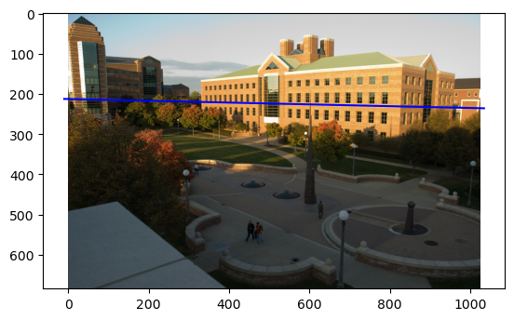

Using the interface, construct the lines on the image that establish that the two gables on the CSL building are the same height. Explain why these lines do so.

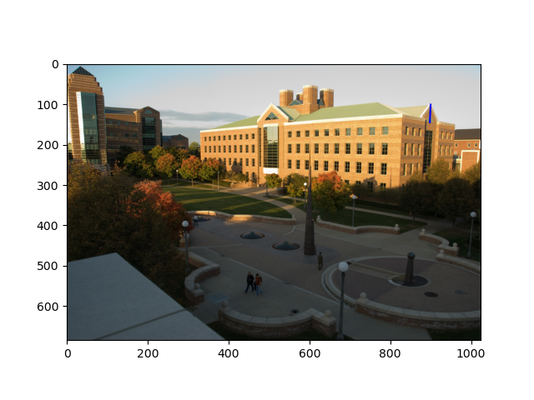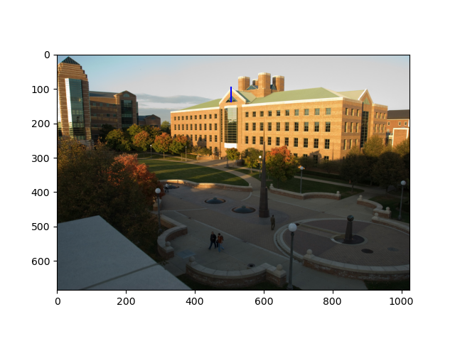

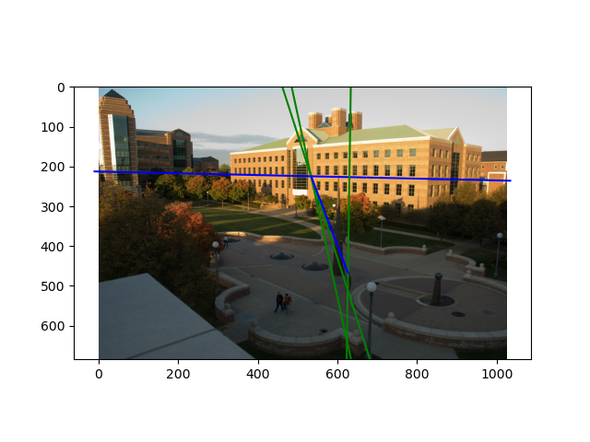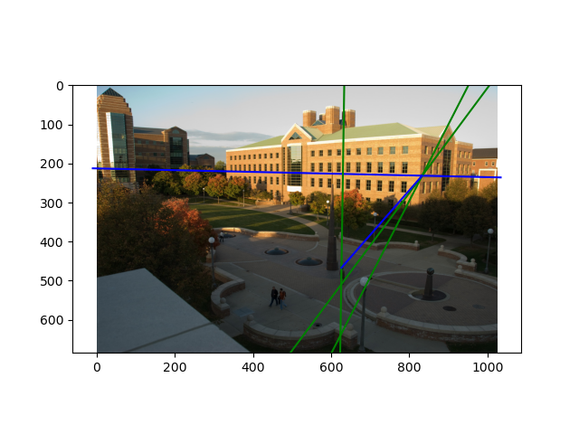

The pictures show that the two gables are the same height by intersecting the vertical reference line at the same position.

# Part 2 Fundamental Matrix Estimation, Camera Calibration, Triangulation:

## For the lab and library image pairs, display your result (points and epipolar lines) and report your residual for both unnormalized and normalized fundamental matrix estimation.

## **Lab:**

unnormalized:

Residual: 2.13043577968693

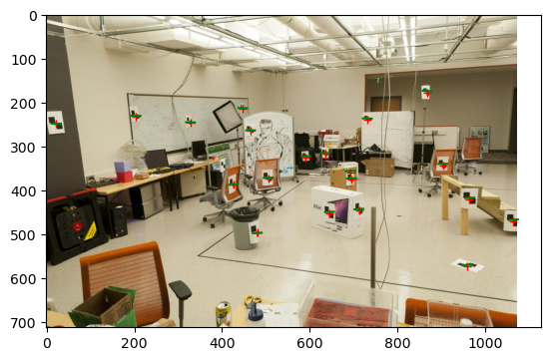

normalized:

Residual: -0.14916275804619036

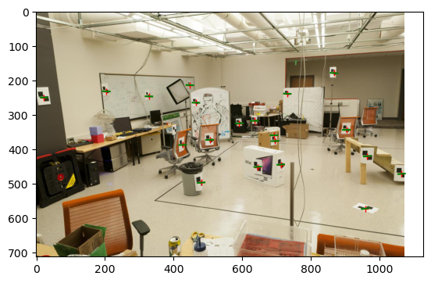

## **Library:**

unnormalized:

Residual: 0.2947076598486313

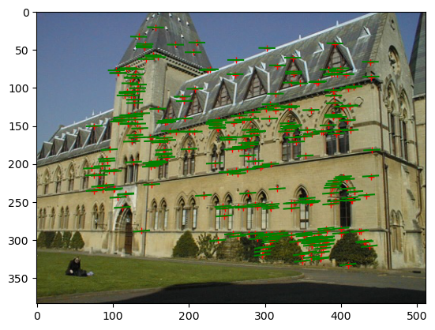

normalized:

Residual: 0.04166594137474641

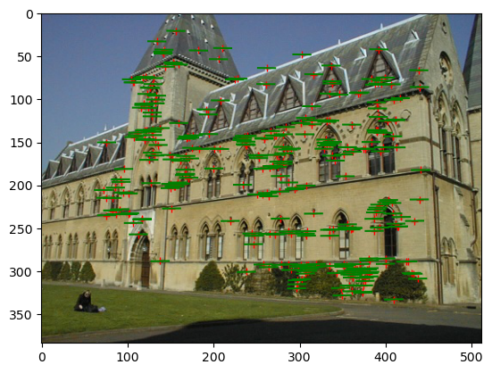

## For the lab image pair, show your estimated 3x4 camera projection matrices. Report the residual between the projected and observed 2D points.

## **Estimated camera projection matrices:**

Camera Projection Matrix 1:

[[-3.09963996e-03 -1.46204548e-04 4.48497465e-04 9.78930678e-01]

[-3.07018252e-04 -6.37193664e-04 2.77356178e-03 2.04144405e-01]

[-1.67933533e-06 -2.74767684e-06 6.83964827e-07 1.32882928e-03]]

calibration residual: 13.545832903514446

Camera Projection Matrix 2:

[[-6.93154686e-03 4.01684470e-03 1.32602928e-03 8.26700554e-01]

[-1.54768732e-03 -1.02452760e-03 7.27440714e-03 5.62523256e-01]

[-7.60946050e-06 -3.70953989e-06 1.90203244e-06 3.38807712e-03]]

calibration residual: 15.54495345362814

## For the lab and library image pairs, visualize 3D camera centers and triangulated 3D points.

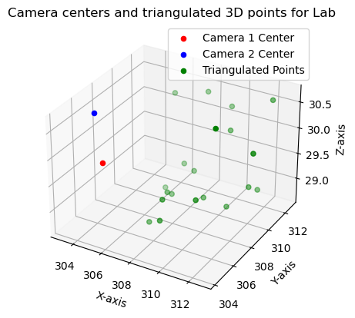

## 

## For the house and gaudi image pairs, display your result and report your number of inliers and average inlier residual for normalized estimation without ground truth matches.

## 

## **house:**

Number of inliers: 42

Average inlier residual: 0.6093184174530849

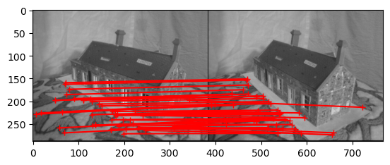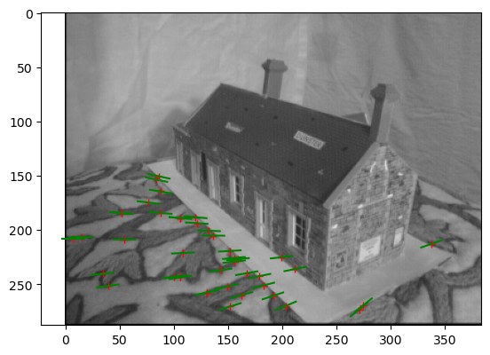

**gaudi:**

Number of inliers: 15

Average inlier residual: 0.5291329656908924

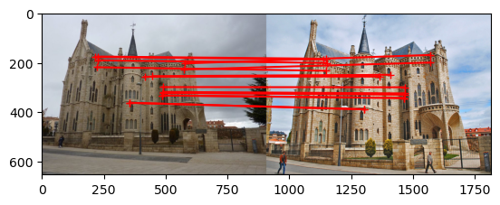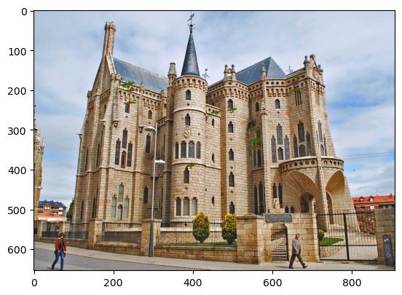

# Extra Credit:

Don’t forget to include references, an explanation, and outputs to receive credit.